# **Introduction**

This system is about employee leave management. This system has the features to raise request about the employee’s leave. Employees can submit requests for leave for a reason with the necessary information and documents. After raising a request admin can check and can approve or reject the request.

## **Scope**

* Upload all documents - *Application *Doctor’s Prescription document (Attachment-jpg,jpeg,png,pdf)
* Request can be raised by employee self.
* Employee can raise leave request reasoning sickness, sickness of a family member, death of a family member, or any other particular reason. Employees can raise leave request for long term or short term or one day.
* There will be Category for leave. Example: sick leave, annual leave and other category of leave.
* Policy and FAQ need to be displayed.
* Admin will approve or reject a request with a comment.
* Employee will get an email notification email when the admin approves or rejects a request.
* Admin and report owner can extract reports with date range and status.

Notification: Basic notification

1. Employee submitted > Admin will get email notification
2. Request approved/rejected > Employee will get email Notification

## **Design Description**

# **Design Description**

## **2.1 Business Process Design**

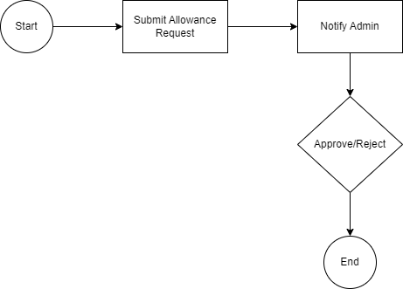

**Figure 1: Business Process Diagram**

## **2.2 Database Design**

**Figure 2: Database Diagram**

## **2.3 Use case diagram**

**Figure 1: Use Case Diagram**

## **2.4Sequence diagram**

**Figure 2: Sequence Diagram**

***App.php :***

***Configs:***

*Name: Employee Leave*

*Key:* **employee_leave**

*Value :*

# **Prototype Design**

## **3.1 Employee Allowance Request**

## 

* Employee self can raise an leave request with all documents - *Application *Doctor’s Prescription document (Attachment-jpg,jpeg,png,pdf)
* Admin can approve or reject a request with a comment.

**DB Operation**

|  |  |
| --- | --- |
| **Table Name** | **Change Type** |
| employee_leave_requests | New Table |

## **3.2 Notification**

After Rising an allowance requesta mail will be sent to the admin containing detailed information. The employee will get a notification email if the request is approved or rejected by the admin

**Email templates**

|  |
| --- |
| **Slug** |
| employee-leave-request-raised |
| employee-leave-reject |
| employee-leave-approved |

## **3.2 Cron**

**Access Permission**

|  |  |  |  |  |
| --- | --- | --- | --- | --- |
| **Module** | **Permission Group** | **Status** | **Access root** | **Actions** |
| Employee Leave | Employee | New | LeaveRequests | * add * leavepolicy * downloadDocs * chooseCategory * view |
| Reporter | New | LeaveRequests | * reporterIndex * reporterView |
| Admin | New | LeaveRequests | * add * adminIndex * adminView * leavepolicy * approve * downloadDocs * chooseCategory * index * members * reject * reporterIndex * reporterView * view |

**Server Architecture**

Below Figure represents how user and server is interacting with each other for mating data communication.

*Fig. 05: Server architecture for* Employee Leave

Following are the description of numbers at server architecture figure #05.

1. Porxy + Load balancer
2. Porxy + Load balancer
3. App/web server
4. App/web server
5. DB primary
6. DB standby
7. Dev + Staging server
8. VIP: Virtual IP between DB
9. VIP: Virtual IP between LB
10. Pragati VM
11. Workday FTP Server

### **Technical Standards**

|  |  |  |
| --- | --- | --- |
| **Technology** | **Database** | **Server** |
| Apache | MySQL DB | Apache |
| PHP |  |  |
| CakePHP3 |  |  |
| MVC |  |  |
| HTML5/CSS/Bootstrap |  |  |
| JavaScript/JQuery |  |  |

*Table 08: Technical Standard*

### **Page Controls**

|  |  |
| --- | --- |
| **Control Name** | **Description** |
| Date picker | select a date range |
| Label | Text Information |
| Button | Action to populate table data |
| Table | To display the report data |
| Hyperlink | To open new window or upload excel file |
| Dropdown | to populate list of data |
|  |  |

*Table 09: Page controls*

# **Traceability to Requirements**

List traceability information to trace the requirements from RS document to Design document.

The locations of design specifications should be mapped to the corresponding locations of the requirements in the RS document.

|  |  |  |
| --- | --- | --- |
| **Document reference Id & Description: (Doc Id from which this document is derived)** | | |
| **Sl No.** | **Reference document**  **Requirement/Feature (Section ID/Name)** | **Design document**  **(Section ID/Name)** |
|  |  |  |

# **Others**

Describe other items like reusable components etc.

# **Acronyms and Glossary**

|  |  |
| --- | --- |
| DMZ | Demilitarized Zone |
| HA | High-availability |
| ITDC | IT Data center |
|  |  |
|  |  |
|  |  |
|  |  |
|  |  |